# Lab # 4

**Objective: To verify the laws of series combinations of resistances using:**

1. **Ohmmeter method.**
2. **Voltmeter-Ammeter method.**

**Equipment:**

* Resistors (R1, R2, R3)
* Digital Multimeter (DMM)
* Ohmmeter
* Voltmeter
* Ammeter
* DC Power Supply
* Connecting wires
* Breadboard

**Theory**

**Series Combination of Resistors:**

When resistors are connected end-to-end in a circuit, they are said to be in series. The total or equivalent resistance Rt of resistors in series is the sum of their individual resistances.

**Rt=R1+R2+R3+…+Rn**

1. **Ohmmeter Method**

An ohmmeter directly measures the resistance of a circuit component. When measuring a series combination of resistors, the ohmmeter should display the total resistance, which should equal the sum of the individual resistances.

1. **Voltmeter-Ammeter Method**

Using Ohm's law (V= IR), the total resistance of a series circuit can be calculated by measuring the total voltage across the series combination and the current through the circuit. The total resistance is then given by:

**Rt=Vt / I**

where Vt is the total voltage and I is the current.

**Procedure**

1. **Ohmmeter Method:**
   1. **Measure Individual Resistances:**
      * Connect the ohmmeter across each resistor (R1, R2, R3) and record their resistances.
   2. **Measure Series Combination Resistance:**
      * Connect the resistors in series.
      * Measure the total resistance of the series combination using the ohmmeter.
      * Record the measured total resistance as Rt (ohm).
2. **Voltmeter-Ammeter Method**
   1. **Set Up the Circuit:**
      * Connect R1, R2, and R3 in series with the DC power supply.
      * Connect the voltmeter across the series combination to measure the total voltage (Vt).
      * Connect the ammeter in series to measure the current (I).
   2. **Measure Voltage and Current:**
      * Switch on the power supply.
      * Record the voltage across the series combination as Vt.
      * Record the current through the series combination as I.
   3. **Calculate Total Resistance:**
      * Calculate the total resistance using the formula Rt = Vt / I.

**Observation**

1. **Ohmmeter Method**

|  |  |
| --- | --- |
| **Resistor** | **Measured resistance** |
| R1 |  |
| R2 |  |
| R3 |  |
| Rt (measured) |  |
| Rt (calculated by R1 + R2 + R3) |  |

1. **Voltmeter-Ammeter Method**

|  |  |
| --- | --- |
| Voltage (Vt) |  |
| Current (I) |  |
| Total resistance (calculated by Rt= Vt/I) |  |

**Results**

* + - Compare the measured total resistance from the ohmmeter method with the sum of the individual resistances.
    - Compare the calculated total resistance from the voltmeter-ammeter method with the sum of the individual resistances.

**Conclusion**

The experiment should confirm that the total resistance of resistors connected in series is equal to the sum of their individual resistances. Both the ohmmeter method and the voltmeter-ammeter method should provide consistent results, verifying the law of series combinations of resistances.

**Safety Precautions**

* + - Ensure all connections are secure and there are no loose wires.
    - Handle the power supply with care to avoid short circuits or electrical shocks.
    - Turn off the power supply when making or breaking connections in the circuit.

**Circuit Diagram:**

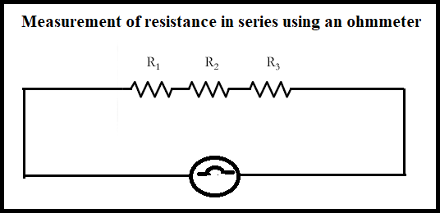

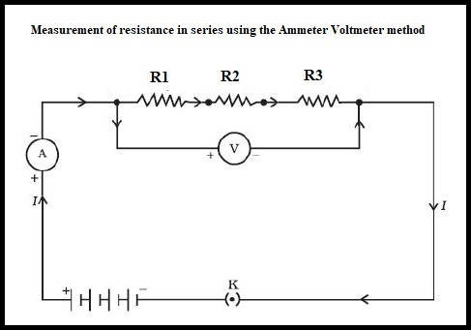

**POST LAB:**

1. What is the formula for the total resistance of resistors connected in series?
2. What does an ohmmeter measure directly in a circuit?
3. What are the two key measurements needed to calculate the total resistance using the voltmeter- ammeter method?
4. How do you calculate the total resistance using the voltmeter-ammeter method?
5. What should be the relationship between the measured total resistance of resistors in series using an ohmmeter and the sum of their individual resistances?